Project Proposal: FurEverFamily Website

ST10474521
WEB DEVELOPMENT
Date: September 26, 2025
Prepared By: Mxolisi Maluleka
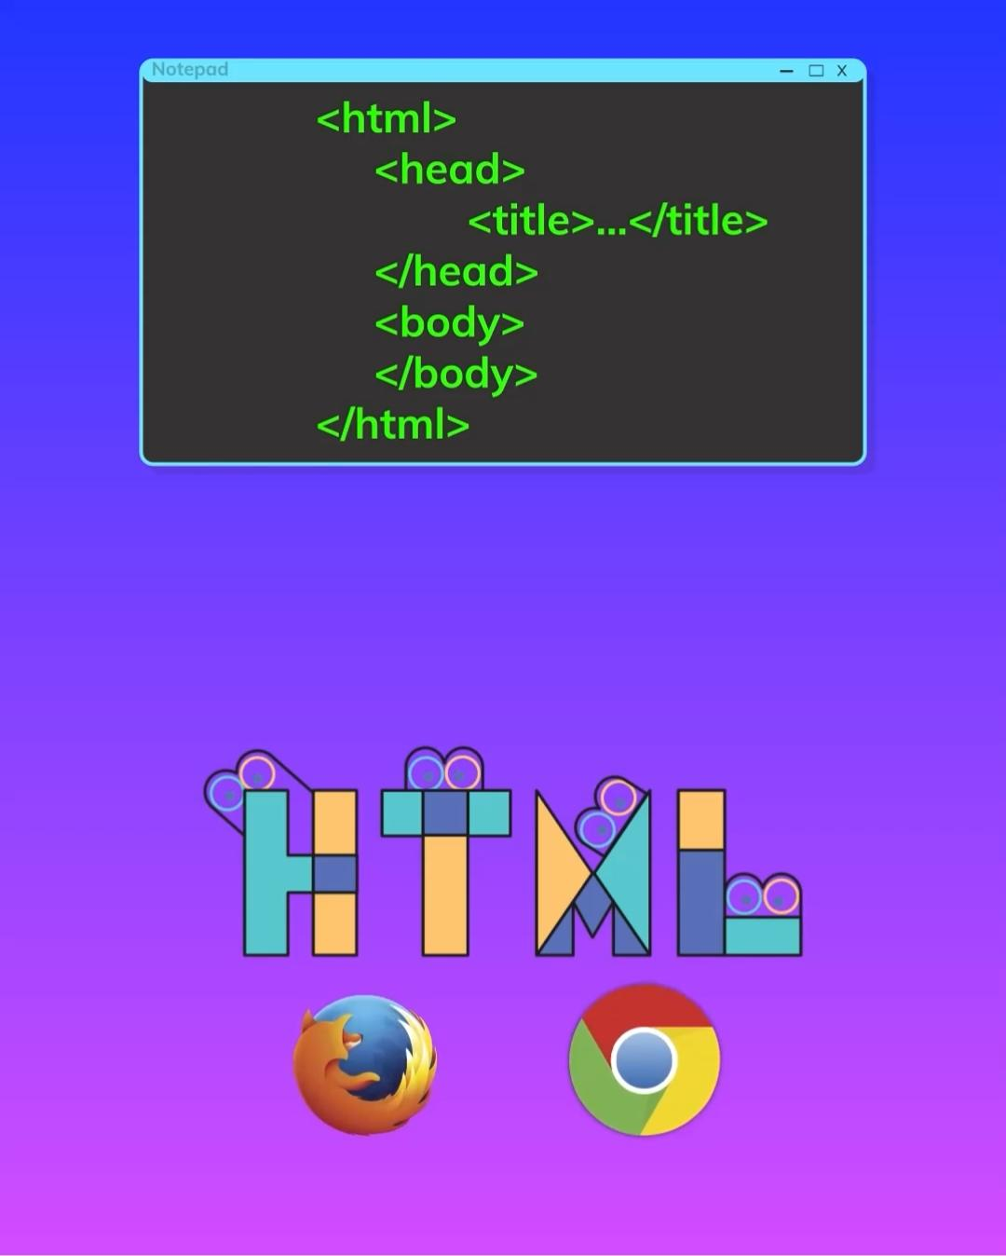

1. Executive Summary
FurEverFamily is a mission-driven initiative dedicated to creating a brighter future for rescued animals. This proposal outlines the plan to develop a modern, user-friendly, and emotionally resonant website that will serve as the primary digital hub for our operations. The website will effectively connect adoptable pets with loving families, support our network of shelter partners, and educate the public on the importance of pet adoption. Our goal is to transform the pet adoption process into an accessible, informative, and heartwarming experience for all.

2. Our Mission & Vision
· Our Mission: To provide a seamless and compassionate online platform that connects rescued animals with their forever families, supporting shelters and promoting the "adopt, don't shop" philosophy.
· Our Vision: A world where every pet has a loving home, and every family can experience the joy of rescue and adoption.

3. Project Goals & Objectives
The FurEverFamily website will be designed to achieve the following key objectives:
· Increase Pet Adoptions: Drastically reduce the time pets spend in shelters by making them highly visible and easily searchable online.
· Support Shelter Partners: Amplify the reach of local shelters and rescue organizations by providing them with a powerful, free-to-use platform.
· Educate the Public: Become a trusted resource for information on pet care, adoption processes, and the benefits of choosing adoption.
· Build a Community: Foster a supportive network of adopters, volunteers, foster families, and donors united by a love for animals.
· Streamline Operations: Simplify the adoption inquiry and screening process for both families and shelter staff.

4. Website Structure & Sitemap
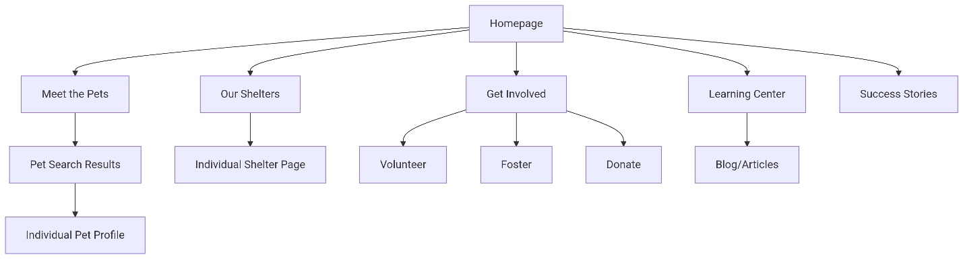
The website will be organized into the following main pages and sections to ensure intuitive navigation and a clear user journey.

Core Page Descriptions:

· Homepage: A warm, welcoming landing page featuring a hero image, a quick search bar, highlighted pets, key mission statement, and clear calls-to-action (e.g., "Adopt," "Volunteer," "Donate").
· Meet the Pets: The core searchable database. Users can filter by species, breed, age, size, location, etc.
· Individual Pet Profile: A dedicated page for each animal with photos, a bio, personality traits, medical info, and an inquiry form.
· Our Shelters: A directory of partner shelters with profiles, contact info, and a direct link to their available pets.
· Get Involved: A section dedicated to ways people can help, with subpages for Volunteering, Fostering, and Donating.
· Learning Center (Blog/Resources): Hosts educational articles, pet care guides, and adoption tips.
· Success Stories: A gallery of photos and testimonials from happy adopters to build trust and inspire action.
· About Us: Details the mission, vision, and team behind FurEverFamily.
· Contact Us: A simple contact form and information.

5. System Architecture & User Flow Diagram

The following chart illustrates the core adoption process for a potential adopter, showing how they interact with the website and how the system manages the data flow.
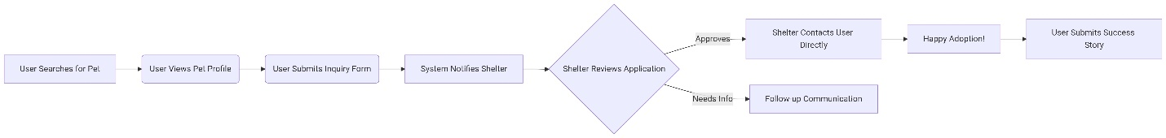

6. Project Timeline & Phases

Phase | Duration | Key Deliverables
1.Discovery & Planning | Weeks 1-2 | Finalized sitemap, wireframes, content plan, technical specifications.
2. Design & Development | Weeks 3-5 | Visual design mockups, functional website built with CMS, shelter portal.
3. Testing & Content Population | Weeks 6-7 | User Acceptance Testing (UAT), bug fixes, loading pet/shelter data, writing blog posts.
4. Launch & Post-Launch | Weeks 8-9 | Website goes live, analytics setup, training for shelter partners, initial marketing.

7. Budget Estimate
The following is a preliminary budget breakdown for the website development.
Category | Description | Estimated Cost
Web Design & User Experience | Custom design, wireframing, prototyping | R2,000 - R3,500
Front-End Development | Building the visual, client-facing part of the site | R3,000 - R5,000
Back End Development | Database, server logic, shelter portal functionality | R4,000 - R6,500
Content Management System | Integration with a user-friendly CMS | R500 - R1,000
Content Creation and Population | Writing initial website content and loading first 50 pet profiles | R1,000 - R2,000
Testing & Quality Assurance | Ensuring functionality across devices and browsers | R500 - R1,000
Project Management | Oversight, communication, and delivery | R1,000 - R1,500
Contingency (10%) | For unforeseen expenses | R1,200 - R2,050
Total Estimated Cost |  | R13,200 - R22,550

Note: This is an estimate. A precise quote will be provided after the Discovery Phase. Ongoing costs (hosting, domain, maintenance) are not included.

8. References & Inspiration
The design and functionality will be informed by best practices from leading and highly-regarded animal welfare sites, including:
· Petfinder: A gold standard for searchable pet databases and shelter networking.
· ASPCA: Excellent resource for credible, educational content on animal care and welfare.
· The Dodo: Effective use of emotional, story-driven content to build community and engagement.
· Best Friends Animal Society: Strong model for promoting various ways to get involved (foster, volunteer, donate).
9. Conclusion
The FurEverFamily website is more than just a tool; it's the digital embodiment of our mission to save lives. This comprehensive plan outlines a clear path to creating a centralized, efficient, and compassionate platform that will significantly increase our impact, helping countless animals find the loving, forever homes they deserve.

We are excited to move forward with the development of this vital resource and officially launch FurEverFamily.com as the premier destination for pet adoption.

Let's give every rescued animal the chance at a FurEverFamily.

For more information, please contact:
FurEverFamily@gmail.com

